Art 101 Art History
Final Exam Study Guide
Chapters 12, 13, 14, & 17

Essay questions: you must write at least 1/2 page for each. These are short essay questions and should be your own thoughts and opinions with nothing taken from other sources. 100 points total

- Discuss the symbolic meanings that fifteenth-century viewers would have comprehended in the objects contained in the domestic environments of either the Merode Alterpiece or the Arnolfini Double Portrait. How have the artists made these objects look so real? 20 points
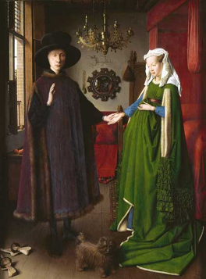

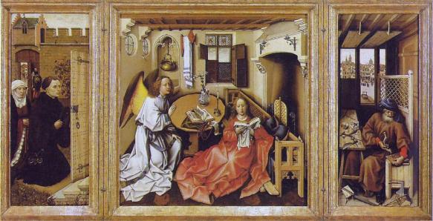

- Define linear perspective. Choose a work that clearly demonstrates its use and discuss how the artist employs this technique. Does perspective affect the way the story is told or the meaning that it conveys? 15 points

- Define the Protestant Reformation and the Counter Reformation. How did these two movements affect art? Choose one piece during the Reformation and one piece created during the Counter Reformation and compare and contrast the two pieces. Be sure to point out changes in style between the two periods. List the title, artist, date, and medium of each piece if known.
20 points

- Discuss the complicated portrayal of space in Velazquez’s Las Meninas. How does this painter differentiate foreground and background? How does he suggest the extension of pictorial space to include the area in front of the picture plane? 15 points
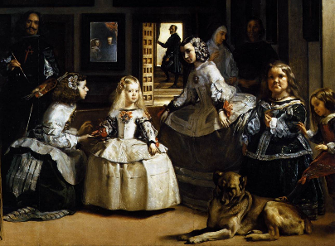

- What event does The Raft of Medusa depict? Was this a true or made up event? Who is the artist and during what period was it painted? Discuss this period in terms of usual subject matter and common characteristics. 15 points
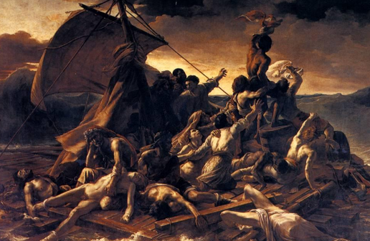

- What is the painting Slave Ship (Slavers Throwing Overboard the Dead and Dying, Typhoon
Coming On) based upon? Who is the artist and during what period was it painted? Discuss what this painting depicts. 15 points
